# WHY GUTENBERG HAD IT RIGHT: Reading Print Books is More Beneficial than eBooks

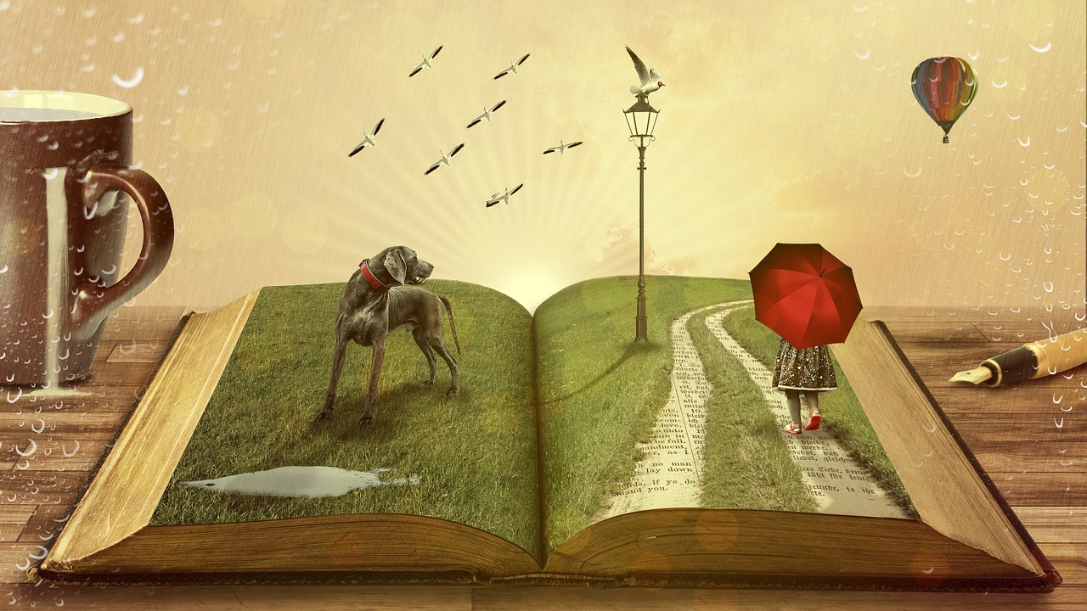

Many of us know that Johannes Gutenberg invented the printing press in 1450. Well, technically, he wasn’t the very first to try out printing. The very first ever printed book, The [Diamond Sutra](https://www.history.com/topics/inventions/printing-press), dates back to 868 A.D. Still, its safe to say, that Gutenberg was the first to perfect and commercialize the printing press. I’m willing to bet, though, that not many know who invented the first eBook. Inspired to promote literacy and enable easy access to free reading material, Michael Hart, invented the eBook in 1971. It was such a hit that soon after, he founded, Project Gutenberg.

In 2011 Hart [stated](https://www.zdnet.com/article/project-gutenberg-founder-and-inventor-of-the-ebook-michael-hart-dies/): “One thing about eBooks that most people haven’t thought much is that eBooks are the very first thing that we’re all able to have as much as we want other than air.” Now that might be a slight exaggeration, but Project Gutenberg has made an impressive [58,000 free eBooks](http://www.gutenberg.org/) available to anyone with access to the internet.

But let’s get one thing straight. Project Gutenberg, isn’t quite what Gutenberg had in mind. The magic found in an ink printed, paper bound book, just isn’t present in electronic books. You see, when you sit down and crack open a printed book, you gain more than just the knowledge you receive through reading eBooks.

1. Reading printed books places you in the middle of the scene and brings you closer to the characters

How does a printed book do this better than an eBook when the contents of each are the same? Well, good question. So here’s a good and simple answer. To read an eBook, you have to use some sort of device that has access to the internet (laptop, tablet, Kindle, Nook, phone). And with that internet access a button away, it is tempting for many to get distracted.

But say you’re not an avid, internet browser. The lure of Buzzfeed has no effect on you, and you’d rather read than talk on the phone or check your mail. That’s great, I’m sure Gutenberg would appreciate that. But the same principles apply.

The human mind and body strive on muscle memory. It’s how we do simple things like walk, breathe, and drive to work and home again while our mind is outside the car. Reading can also be done with muscle memory. But for this to work best, your body must remember that certain feeling or certain que that indicates its time to read. There is no better indicator for this, than the feel and smell of a paper book. That device you use to read your eBook will not work as well for this, because we use the device, or similar devices, to do many different things.

Should you talk on the phone? Check your email or browse the internet? How about post an Instagram photo? When you do this all on the same device that you read your eBook on, your body has no specific memory of what it is meant to be doing when it feels that device. Contrary, when you feel and smell a paper book, your body and mind immediately prepare themselves to read, and you are then able to fully immerse yourself in the plot, characters, and conflict without distraction.

1. Printed books provide the opportunity to read in fun, unique, and challenging locations

Where do you typically read? In bed? On a squishy lounge chair? Everyone has a favorite reading nook. But what if you want a change in scenery? Perhaps you want to read in a hot bubble bath. Or maybe you want to bring your book on the beach. While these alternative reading locations are relatively common, they can be largely disabling to those who wish to read eBooks.

The number once concern in these locations is of course, water. While some devices are water resistant, many are not, or are only so at an extra cost. Some would argue that paper isn’t water proof either, and the argument stands if the book is left soaking a long time. I promise, though, that your printed book will fare better than your eBook, if it ever decides to jump in for a quick swim. Just lay your printed book out in the sun, and it will be as usable as it was before.

Reading a printed book also allows for more unique reading locations. For some ideas, try hiking and camping the Appalachian trail while reading A Walk in the Woods, or horseback riding cross country while reading All the Pretty Horses! For those of you who are real adventure seekers, the thrill of placing yourself in challenging settings with the characters may leave you wanting more.

Even if you don’t have the time or money to go on crazy travels with book characters, reading in just a nearby field or forest can provide a sense of connection to the plot and setting. Reading an eBook in some of these unique settings though can be difficult if your device runs out of battery. While plants do make energy from the sun, it does not come in a form that will charge your tablet. Additionally, travel and adventure can take a toll on both you, your gear, and personal belongings. I would rather carry a printed book in my bag when rock scrambling, than an expensive eBook device. The choice is left up to you, though.

1. Printed books can start both conversations and friendships

Some people can focus fine on an eBook. Others have quick reflexes, water resistant devices, and portable battery packs. Reading a printed book though, has the power, over any eBook to start conversations and lead to friendships.

People spend anywhere from minutes to hours a day staring into electronic devices. People use their phones, tablets, and laptops in the bathroom, on the bus, in the hall ways, in the classrooms, at work…you name a place, and I bet people are there right now using electronic devices. What I mean to say, is that if someone were out reading an eBook, you would never know they were reading a book. They could be doing a number of other activities on their device, and frankly it would be rude to ask what they were doing. If you see someone out reading a printed book though, or someone sees you reading a printed book, it is acceptable, and perhaps even friendly, to comment on the book. Maybe you saw the title and are interested in learning more, or maybe it happens to be your favorite book! The potential is limitless and it can be a start to a great conversation that wouldn’t have happened, if the material had been in eBook form.

These conversations may be a just a time passer or a source of new knowledge. Furthermore, though, these conversations could start lasting friendships! Even if a friendship is not started through the act of reading, using printed books can help develop and nurture existing relationships. Though Project Gutenberg has made thousands of eBooks free to the public, many eBooks still cost money. As such, sharing and exchanging books with friends is a great way to save money! While I love my friends, though, I would never part with my electronic device long enough for them to read the book I own. I would, however, be more than happy to loan them a printed book.

So next time you go to purchase an eBook, consider purchasing it in printed form instead! The printed book could be the difference in your level of focus, your connection to the plot, characters and setting, and your quality of friendships. I promise you will find the magic of a plain, old, original, Gutenberg inspired, printed book. Happy reading!